Subject | land contract
Link to Outlook Item | Click here
From | Josh Petersen
To | photos@onedrive.com
Sent | 6/6/2025, 12:25:41 AM

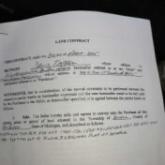
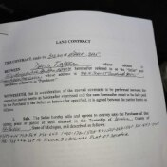
2786269b-c077-4b2e-9417-503b73b073b5.jpg

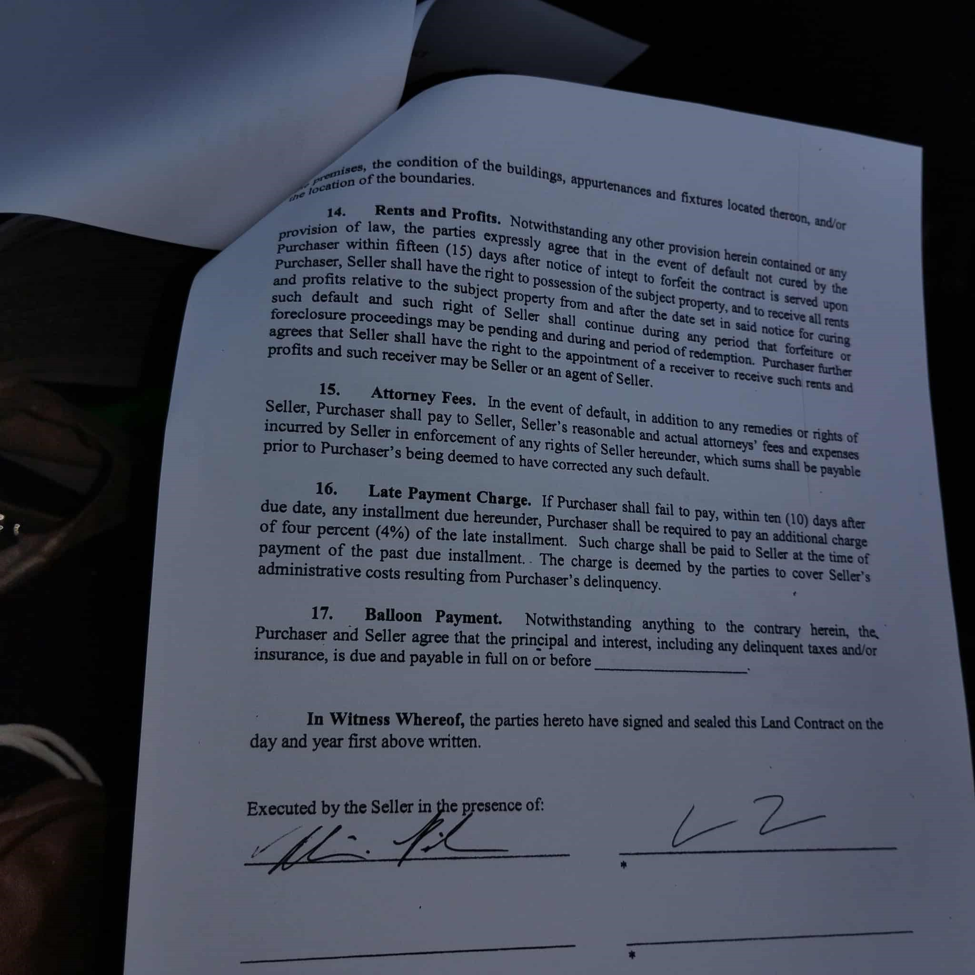
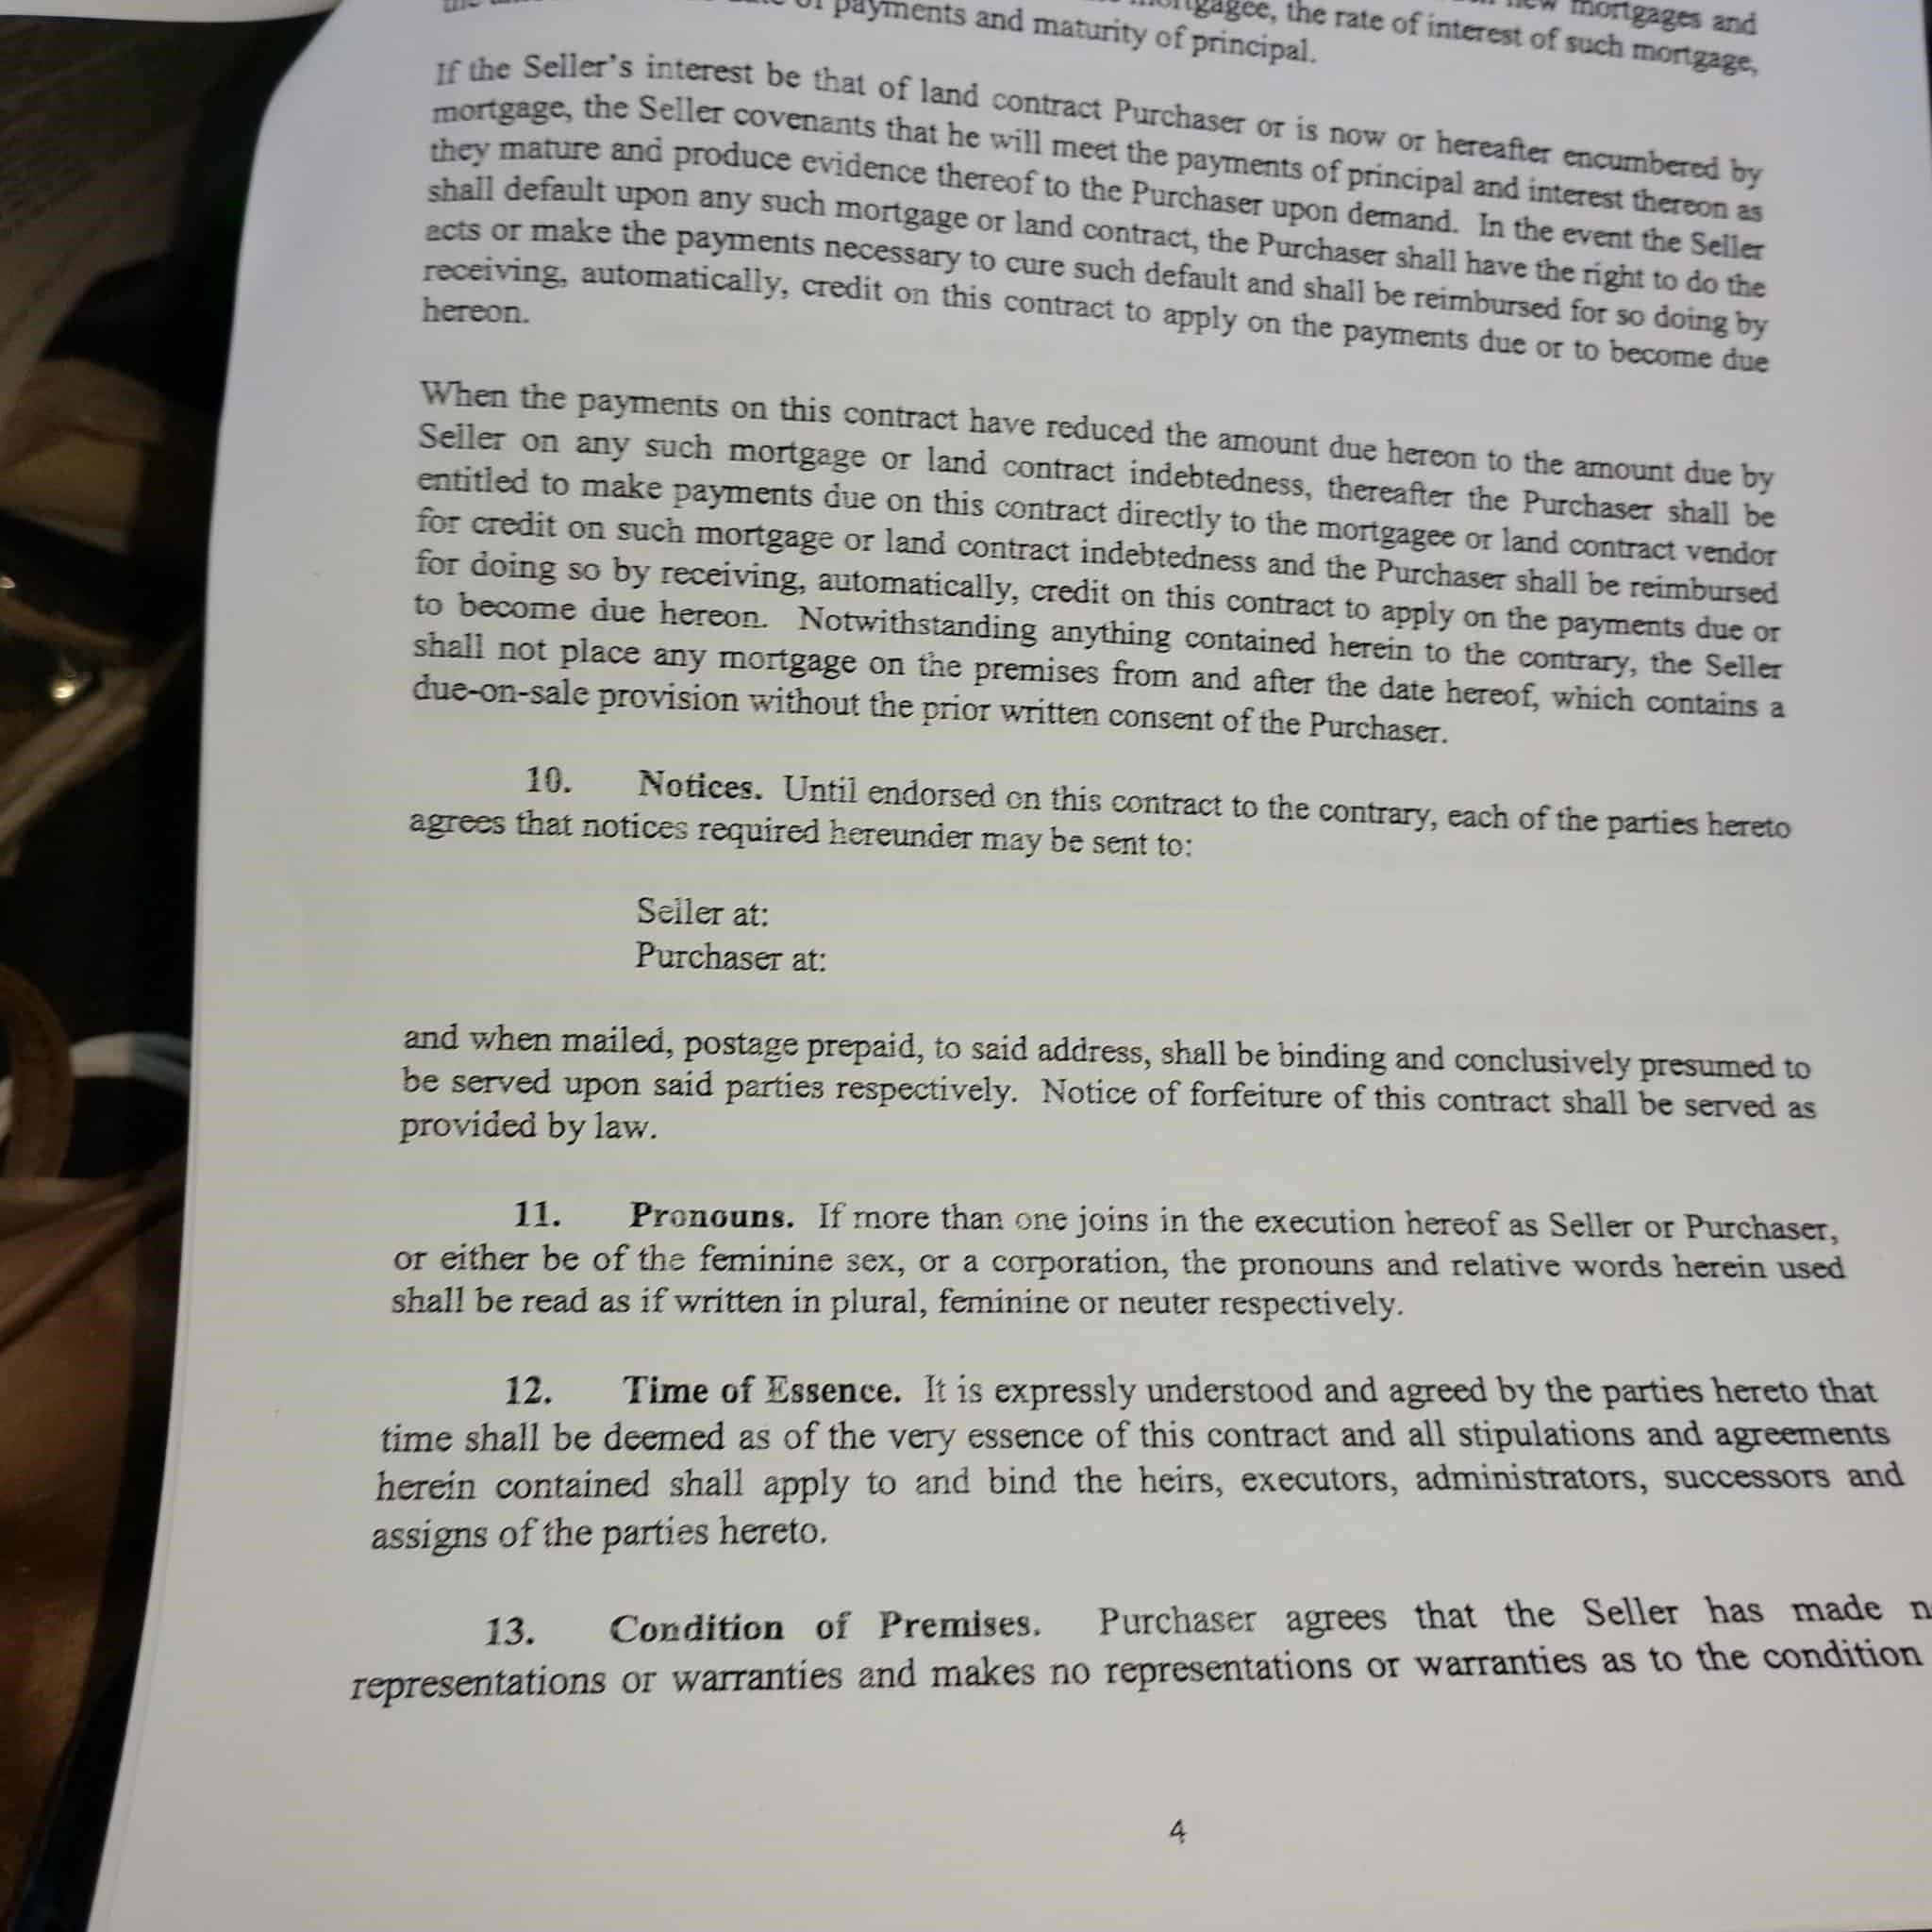
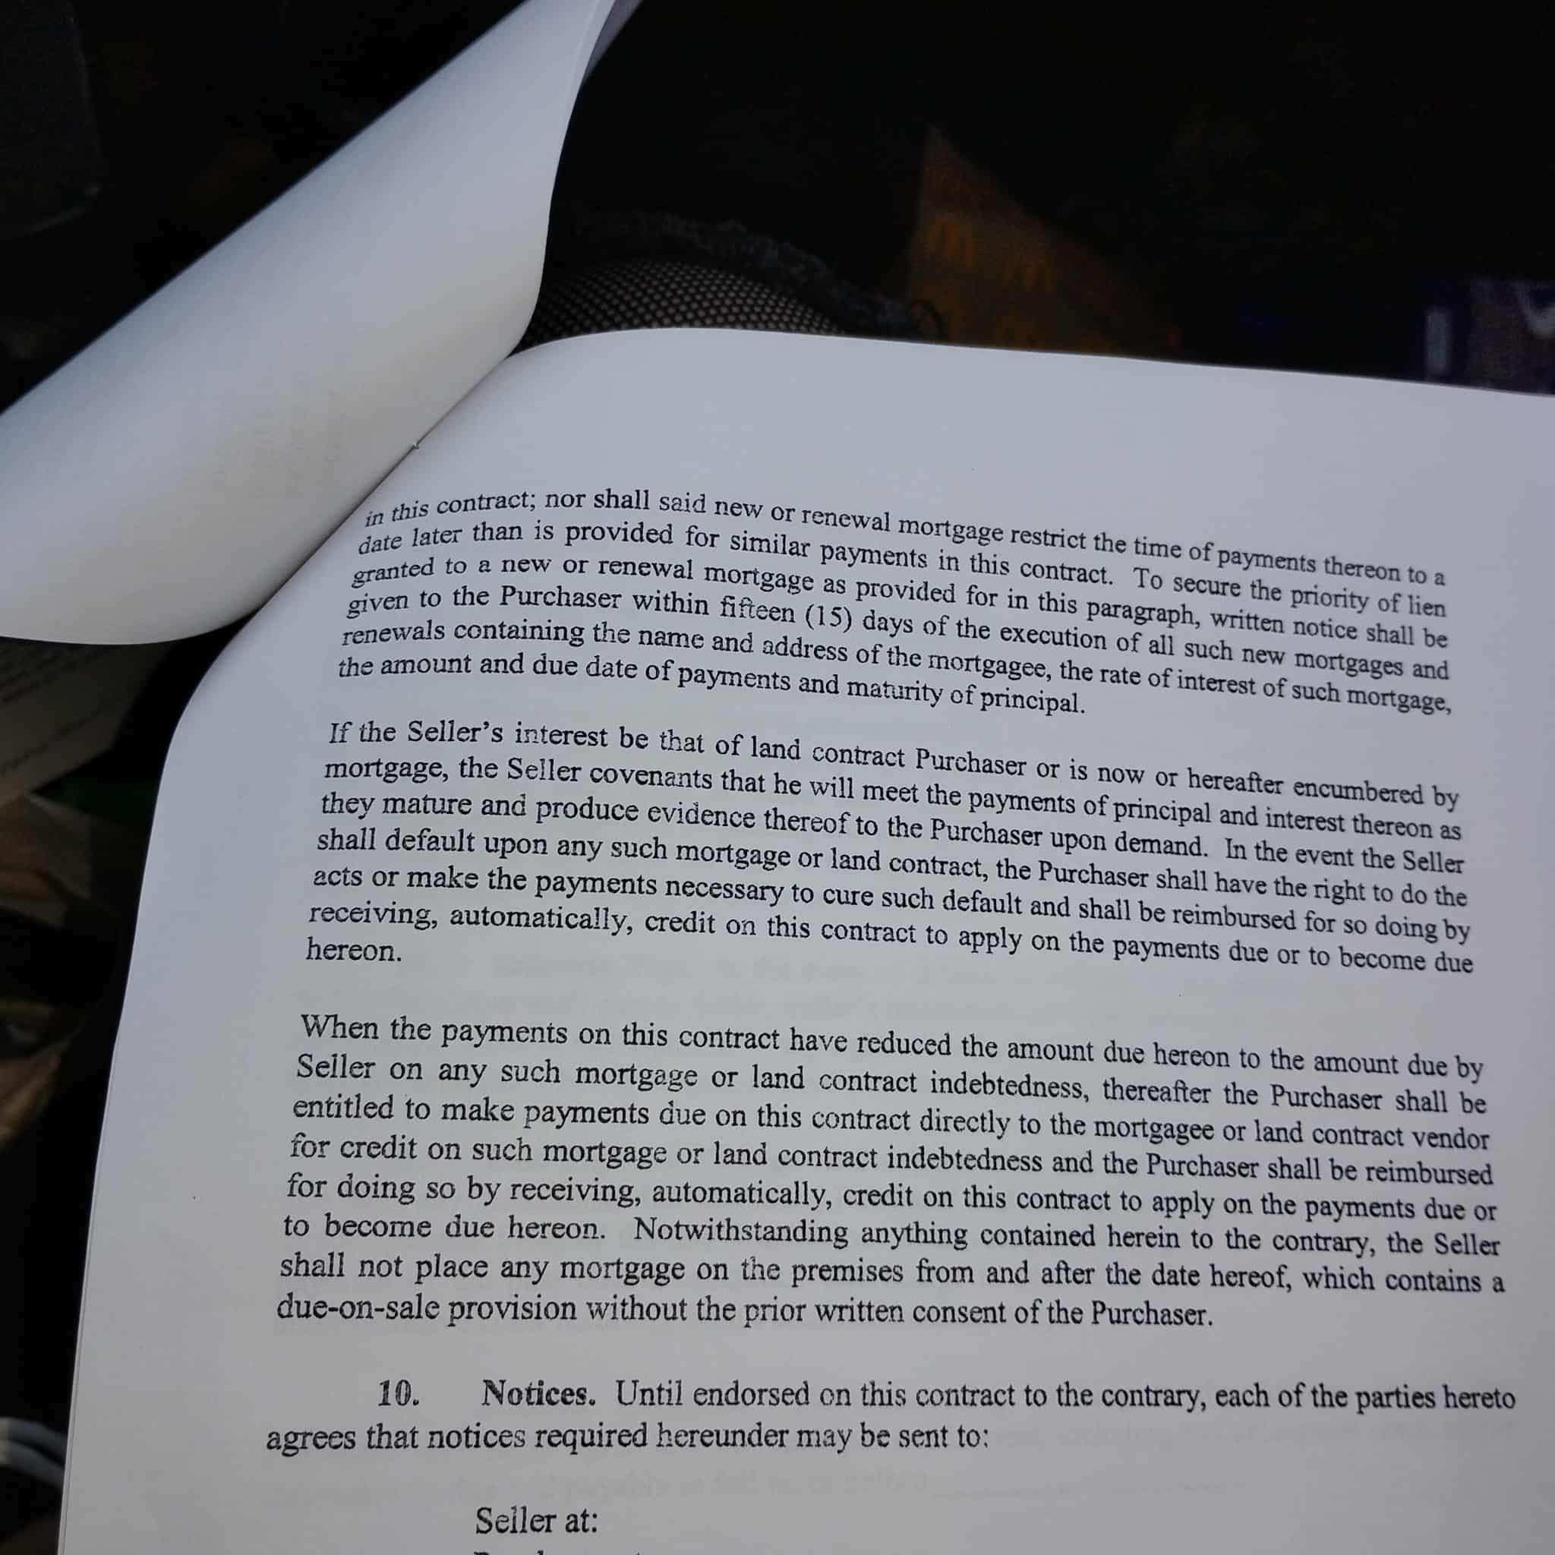
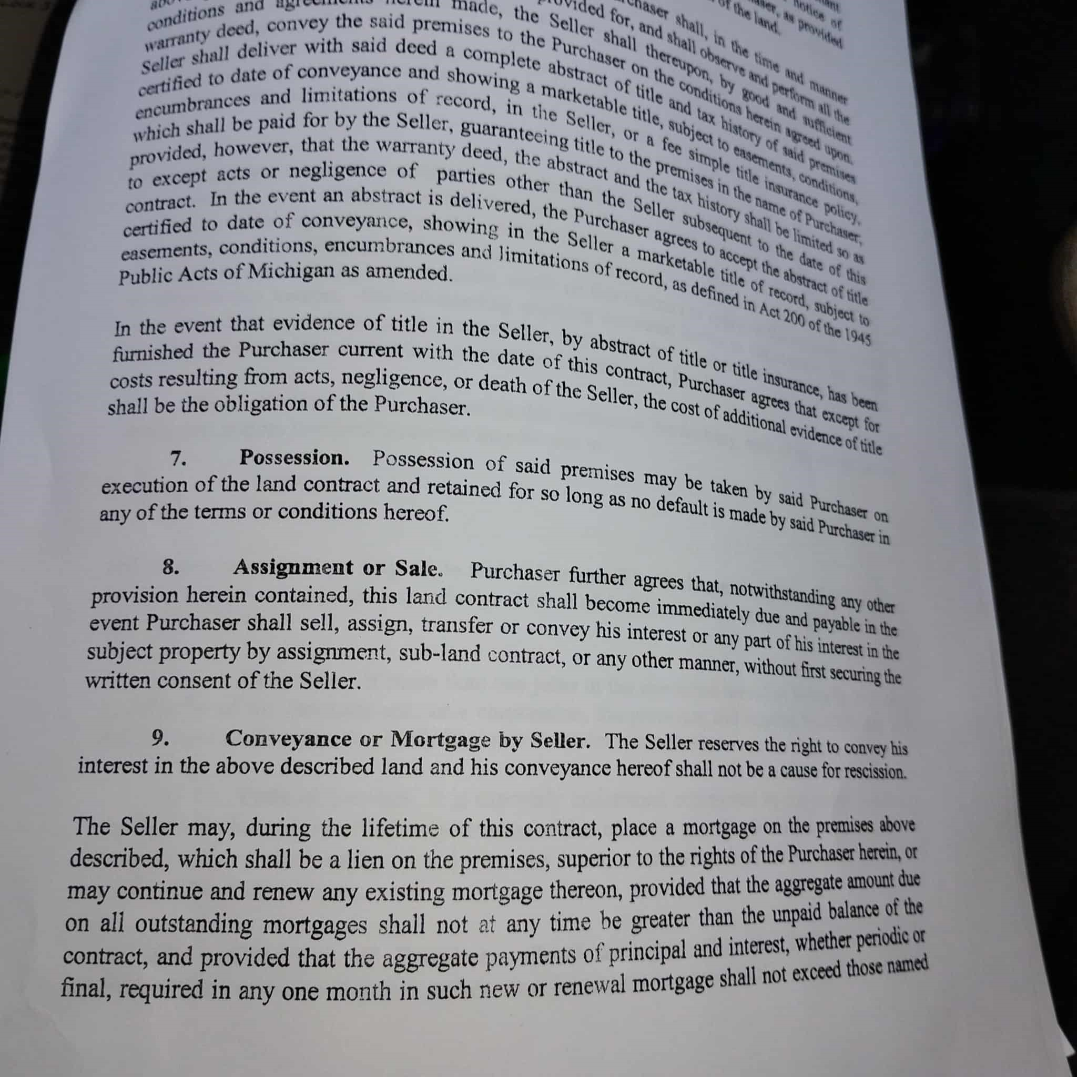
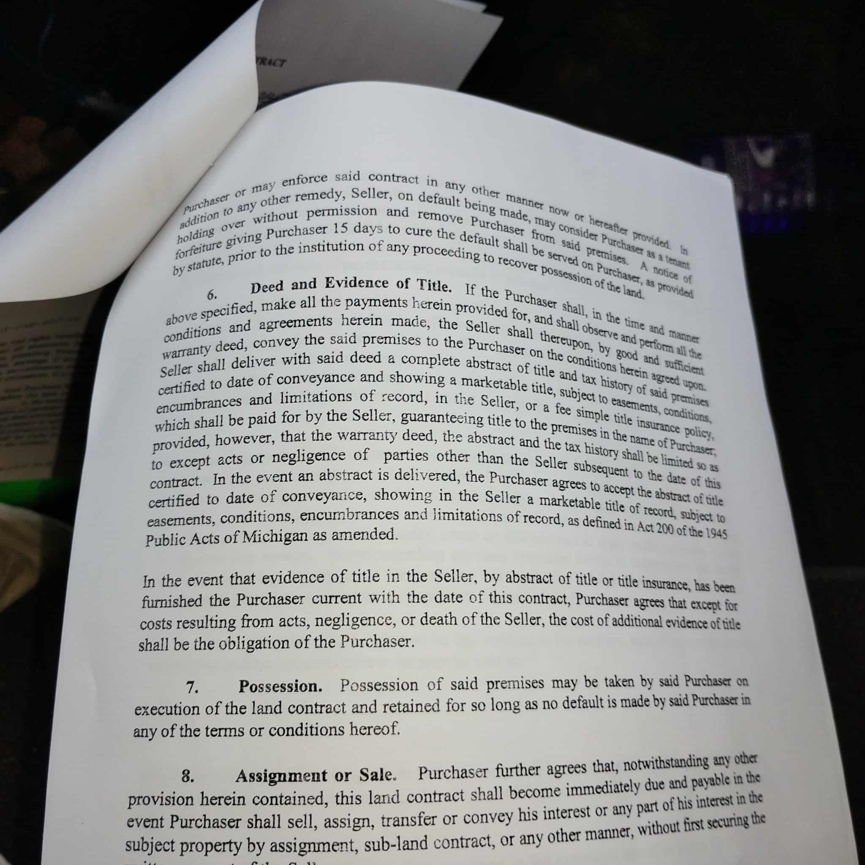
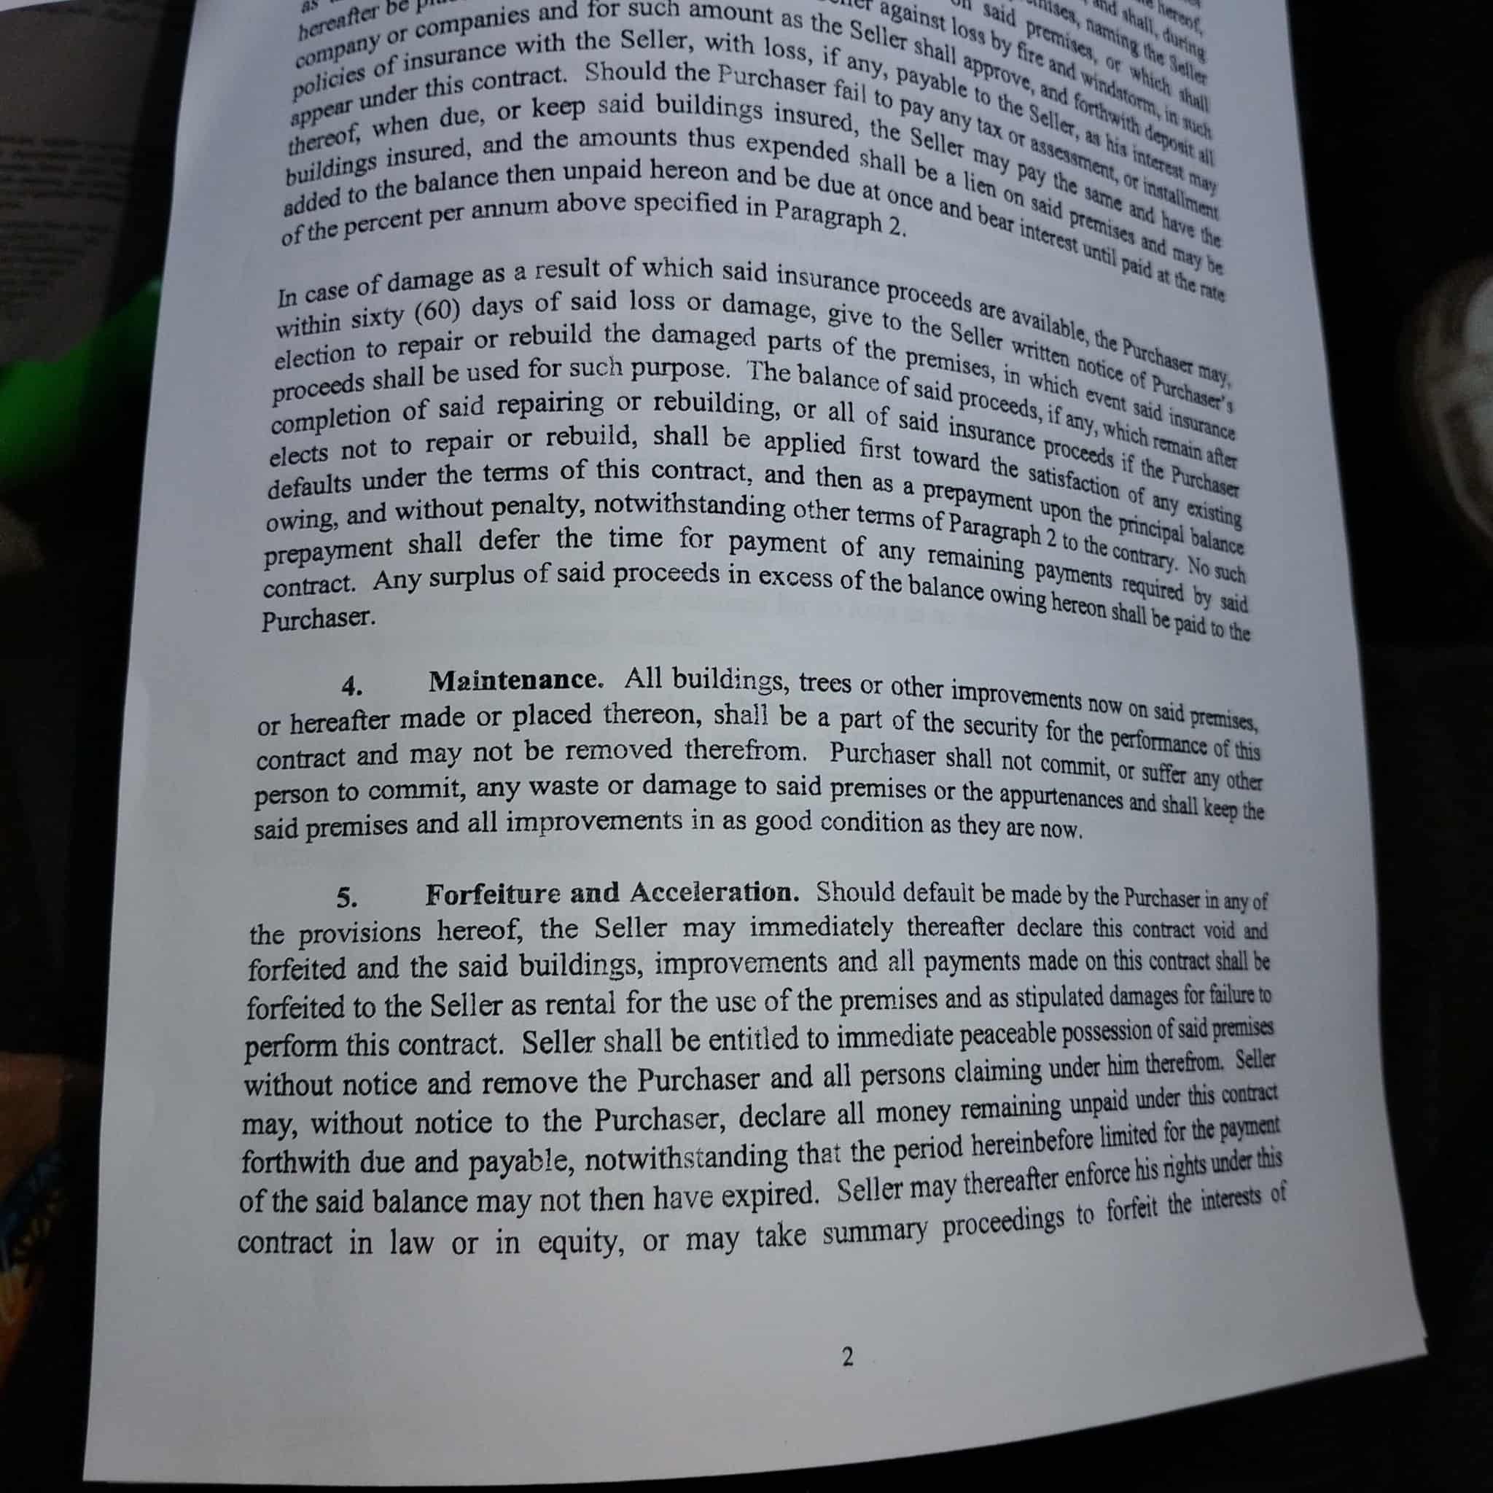
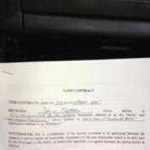
Subject
land contract
Link to Outlook Item
Click here
From
Josh Petersen
To
photos@onedrive.com
Sent
6/6/2025, 12:25:41 AM

2786269b-c077-4b2e-9417-503b73b073b5.jpg

the condition of the buildings, appurtenances and fixtures located
r- don of the boundaries.
14. Rents and Profits. Notwithstanding any other
vision of law, the parties expressly agree that in the event of default not cured by the
purchaser within fifteen (15) days after notice of to forfeit the contract is served upon
purchaser, Seller shall have the right to possession ofthe subject property, and to
and profits relative to the subject property from and after the date set in said notice for
such default and such right of seller shall continue during any period that
foreclosure proceedings may be pending and during and period of Pm-chaser
agrees that Seller shall have the right to the appoinu-nent of a receiver to such rents
profits and such receiver may be Seller or an agent of Seller.
15. Attorney Fees. In the event of default, in addition to any remedies or r'üts of
Seller, Purchaser shall pay to Seller, Seller's reasonable and actual attorneys' fees and expenses
incurred by Seller in enforcement of any rights of Seller hereunder, which sums shall be payable
prior to Purchaser's being deemed to have corrected any such default.
16. Late Payment Charge. If Purchaser shall fail to pay, within ten (10) days after
due date, any installment due hereunder, Purchaser shall be required to pay an additional charge
of four percent (4%) of the late installment. Such charge shall be paid to Seller at the time of
payment of the past due installment.. 'Ihe charge is deemed by the parties to cover Seller's
adminisfrative costs resulting from Purchaser's delinquency.
17. Balloon Payment. Notwithstanding anything to the contary haein, the
Purchaser and Seller agree that the prineipal and interest, including any delinquent taxes ador
insurance, is due and payable in full on or before
In Witness Whereof, the parties hereto have signed and sealed this Lnd Contact on the
day and year first above
Executed by the Seller in ep esence of:
Payments and matcrity of principal.
ee, the rate of interest of such
If the Seiler's interest be that of land contract Purchase
the seller covenants that he will meet the payments ofpnncipal and interest
shall default upon any such mortgage or land contraq the Purchaser shall have the to do the
necessary to cure such default and shall be reimbursed for so doing by
ræeiving, automatically, CTedit on this contract to apply on the payments due or to become due
the payments on this contract have reduced the amount due hereon to the amount due by
Seller on any such mortgage or land contract indebtedness, thereafter the Purchase be
entitled to make payments due on this contract directly to the mortgagee or land contract vendor
for credit on such mortgage or land contract indebtedness and the Purchaser shall be reimbursed
for doing so by automatically, credit on this contract to apply on the payments due or
to become due hereom Now;ithstanding anything contained herein to the cor&ar-y, the Seiler
shall not place any mortgage on the premises from and after the date which contains a
due-on-sale provision without the prior uritten consent of the Purchaser
10. Notices. Until endorsed on this contract to the contrary, each of the parties haeto
agrees that notices required hereunder may be sent to:
Seller at:
Purchaser at:
and when mailed, postage prepaid, to said address, shall be binding and conclusively presumed to
be served upon said parties respectively. Notice of forfeiture of this contract shall be served as
provided by law.
11. Pronouns. If more than one joins in the execution hereof as Seller or Purchaser,
or either be of the feminine sex, or a corporation, the pronouns and relative words herein used
shall be read as if written in plural, feminine or neuter respectively.
12. Time of Essence. It is expressly understood and agreed by the parties hereto
time shall be deemed as of the very essence of this contract and all stipulations and ageements
herein contained shall apply to and bind the heirs, executors, administrators, successors
assigns of the parties hereto.
13. Condition of Premises, Purchaser agrees that the Seller has
representations or warranties and makes no representations or warranties as to the
4
payments and maturity of principal
mortgage the Seller covenants that he will meet the payments of principal and interest thereon as
of is now or hereafter encumbered by
shall default upon any such mortgage or land contra
pets or make the payments necessary to cure such default and shall be reimbursed for so doms by
recerving automatically credit on this contract to apply on the payments due or to become due
When the payments on thi
contract have reduced the amount due hereon to the amount due by
Seller on any such mortgage or land contract indebtedness thereafter the Purchaser shall be
For credit on such mortgage or land contract indebtedness and the Purchaser shall be reimbursed
for doing so by receiving
tomatically credit on this contract to apply on the payments due of
Notwithstanding anything contained her
sale provision without the prior written consent of the Purchaser
agrees that notices required hereunder may be sent to
and when mailed postage prepaid to said address shall be binding and conclusively presumed to
be served upon said parties respectively
provided by law
or either be of the feminine sex or a corporation the pronouns and relative words herein used
time shall be deemed as of the very essence of this contract and all stipulations and agreements
herein contained shall apply to and bind the heirs executors administrators successors and
Purchaser agrees that the Seller has made in
representationsor warranties and makes no representations of warranties as to the condition
this contract; nor shall said new or renewal mongage restrict the time ofpayments thereon to a
date than is provided for similar payments in this contract. To secure the priority of lien
to a new or renewal mortgage as provided for in this paragraph, written notice shall be
given to the Purchaser within fifteen (15) days of the execution of all such new mortgages and
renewals containing the name and address of the mortgagee, the rate of interest of such mortgage,
the amount and due date of payments and maturity of principal.
If the Seller's interest be that of land contract Purchaser or is now or hereafter encunbered by
mortgage, the Seller covenants that he will meet the payments of principal and interest thereon as
they mature and produce evidence thereof to the Purchaser upon demand. In the event the Seller
shall default upon any such mortgage or land contract, the Purchaser shall have the right to do the
acts or make the payments necessary to cure such default and shall be reimbursed for so doing by
receiving, automatically, credit on this contract to apply on the payments due or to become due
hereon.
When the payments on this contract have reduced the amount due hereon to the amount due by
Seller on any such mortgage or land contract indebtedness, thereafter the Purchaser shall be
entitled to make payments due on this contract directly to the mortgagee or land contract vendor
for credit on such mortgage or land contract indebtedness and the Purchaser shall be reimbursed
for doing so by receiving, automatically, credit on this contract to apply on the payments due or
to become due hereon. Notwithstanding anything contained herein to the conEary, the Seller
shall not place any mortgage on the premises from and after the date hereof, which contains a
due-on-sale provision without the prior written consent of the Purchaser.
Notices. Until endorsed on this contract to the contrary, each of the parties hereto
agrees that notices required hereunder may be sent to:
Seiler at:
payments thereon to a
the amount and due date of payments and maturity of principal
they mature and produce evidence thereof to the Purchaser upon demand In the event the Seller
ano
made, the Seller sha
shall deliver with said deed a complete abstract
to date of conveyance and showing a marketable
shall be paid for by the seller, guaranteeing
provided, however, that the warranty deed, the abstract and
to except acts or negligence of parties other than the
contract. In the event an abstract is delivered, the Purchaser
certified to date of conveyance, showing in the seller a marketable f
In the event that evidence of title in the seller, by abstract of title or title
fimished the Purchaser current with the date of this contract,
e seller, the cost of
shall be the obligation of the Purchaser.
Possession. Possession of said premises may be taken by said
7.
execution of the land contract and retained for so long as no default is by
in
Assignment or Sale. Purchaser further agrees that, notwithstanding any othe
8.
provision herein contained, this land contract shall become immediately due and payable inthe
event Purchaser shall sell, assign, transfer or convey his interest or any part of his interest in the
subject property by assignment, sub-land contract, or any other manner, without first securingthe
wHtten consent of the Seller.
9.
Conveyance or Mortgage by Seller. The Seller reserves the right to convey his
interest in the above described land and his conveyance hereof shall not be a cause for rescissiom
The Seller may, during the lifetime of this contract, place a mortgage on the premises above
described, which shall be a lien on the premises, superior to the rights ofthe Purchaserherein,ot
may continue and renew any existing mortgage thereon, provided that the aggregate amount due
on all outstanding mortgages shall not at any time be greater than the unpaid balance of the
contract, and provided that the aggregate payments of principal and interest, whether periodic or
final, required in any one month in such new or renewal mortgage shall not exceed those named
conditions and my
provided
al Ghul deliver with said dood a complex!
abstract . on the Up
certified to d
of chile
of guaranteeing title to the premises is the
provided however that the warranty deed . title
the Seller
name of Purchases .
certified to date of
conveyance showing in the Seller a meeting to accept the state of the
subsequent to the date of this
is defined in Act 200 of the GAS
y abstract of tile or title insurance
I said Purchases on
enforce said contract in any other manner
or roay
addition to any other remedy, seller, on default being made, may
over without permission and remove Purchaser
giving Purchaser 15 to cure the default
statute, prior to the institution of any proceeding to recov
er possessi
Deed and Evidence of Title. If the Purchas
on of the larå
above specified, make all the payments herein provided for, and shall o' the
conditions and agreements herein made, the Seller shall th bsen, time and
warranty deed, convey the said premises to the Purchaser on thtpon' by goco•e
Seller shall deliver with said deed a complete abstract of title and
certified to date of conveyance and showing a marketable title, subject to
Ory of said •n.
encumbrances and limitations of record, in the Seller, or a fee simple title
which shall be paid for by the seller, guaranteeing title to the premises in the
provided, however, that the warranty deed, the abstract and the history shall be limited
to except acts or negligence of parties other than the seller subsequent
contract. In the event an abstract is delivered, the Purchaser agees to accept the
certified to date of conveyance, showing in the Seller a marketable title subject to
easements, conditions, encumbrances and limitations of record, as defined in Act 200 oftåe 1945
Public Acts of Michigan as amended.
In the event that evidence of title in the Seller, by abstract of title or title insurance, has bee
furnished the Purchaser current with the date of this contract, Purchaser agees that except
costs resulting from acts, negligence, or death of the Seller, the cost of additional oftitle
shall be the obligation of the Purchaser.
Possession. Possession of said premises may be taken by said Purchase on
execution of the land contract and retained for so long as no default is madeby said Purchaser
any of the terns or conditions hereo€
Assignment or Sale. Purchaser further agrees that, noNithstanding any
provision herein contained, this land contract shall become immediately due and pa»ble in the
event Purchaser shall sell, assign, transfer or convey his interest or any part ofhis interest inthe
subject property by assignment, sub-land contract, or any other manner, without first sewringthe
any other
furniture giving Purchases 15 days ?
holding
shall be served on Purchases
of the land
is provided
in the time and manner
something good convey the cul promises to the Purchases meupon to the by
I good and
Seller shall deliver withsaid deed a complete abstract of the . dillons here to her
subject to easements conditions.
provided however that the warranty deed the abstract and the way to the same of Plumbing
shall be limited so as
contract In the event an abstract is delivered the Purchases are "back to the date of ?
assign transfer or convey his interest or any part of his interest in the
event Purchaser shall sell
against log
Of insurance with the seller, with loss, if any,
this contract. Should the Purchaser fail
thereof, when due, or keep said buildings insured, the
buildings insured, and the amounts thus expended shall be
ofthe percent per annum above specified in paragraph 2. and
In case of damage as a result of which said insurance proceeds are available, the
the
sixty (60) days of said loss or damage, give to the seller
election to repair or rebuild the damaged parts of the premises, in
proceeds shall be used for such purpose. The balance of said proceeds, if
completion of said repairing or rebuilding, or all of said
event
insurance
elects not to repair or rebuild, shall be applied first toward the
defaults under the terms of this contract, and then as a .
owing, and without penalty, notwithstanding other terms of Paragaph 2 to the pnncipaibtceg
prepayment shall defer the time for payment of any remaining NOÄich
confi-act. Any surplus of said proceeds in excess ofthe balance
4. Maintenance. All buildings, trees or other improvements now on said
or hereafter made or placed thereon, shall be a part of the security for the performance ofthis
confract and may not be removed therefrom. Purchaser shall not commit, or suffer any other
person to commit, any waste or damage to said premises or the appurtenances shdl keep the
said premises and all improvements in as good condition as they are now.
Forfeiture and Acceleration. Should default be madebythePurchaserinanyof
5.
the provisions hereof, the Seller may immediately thereafter declare this contract void
forfeited and the said buildings, improvements and all payments made on this contact shdl be
forfeited to the Seller as rental for the use of the premises and as stipulated damages for failureto
perform this contract. Seller shall be entitled to immediate peaceable possession ofsaidpremises
without notice and remove the Purchaser and all persons claiming under him therefrn Sella
may, without notice to the Purchaser, declare all money remaining unpaid under this contact
forthwith due and payable, notwithstanding that the period hereinbefore limited for the papet
of the said balance may not then have expired. Seller may thereafter enforcehisrightsundathis
contract in law or in equity, or may take summary proceedings to forfeit the of
2
Formatter Of Companies and for such amount an the a going
hereafter Do !
prentis and
defaults under the forms of this contract and then as a . all the satisfi !
the other terms of Paragraph 2 to the
contrary No such
shall be paid to the
contract and may not be removed therefrom
may without notice to the Purchaser declare all money remaining unpaid under this over

e8abe863-ca50-43ad-b6dc-de074434d4c2.jpg

OCR Error: Failed to load image
See this Instagram photo by @unfreaky: https://www.instagram.com/p/BvsjJHXhlOq/?utm_source=ig_web_button_share_sheet

Sent from Mail for Windows 10

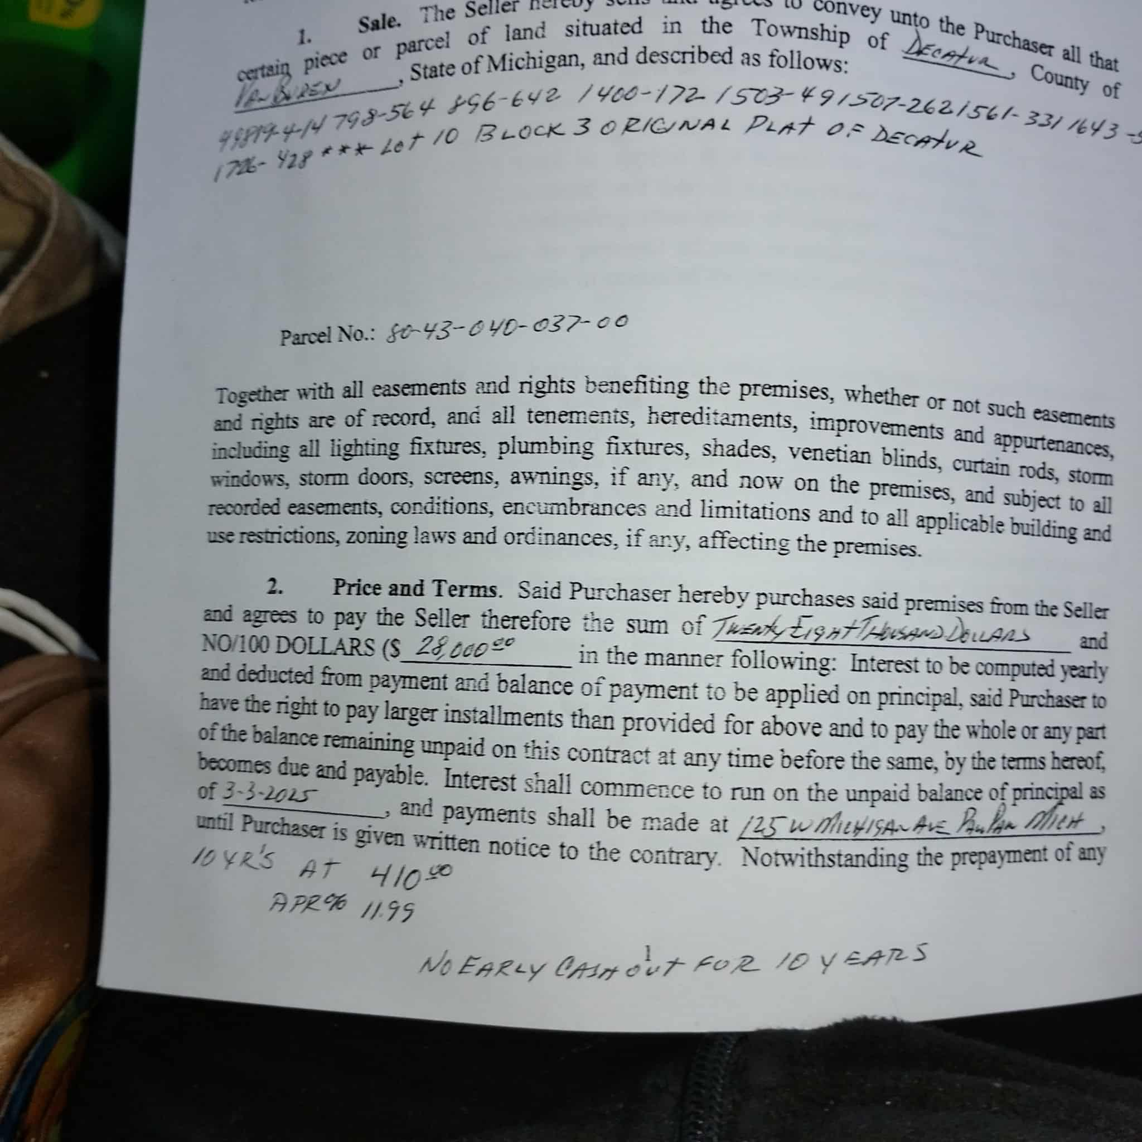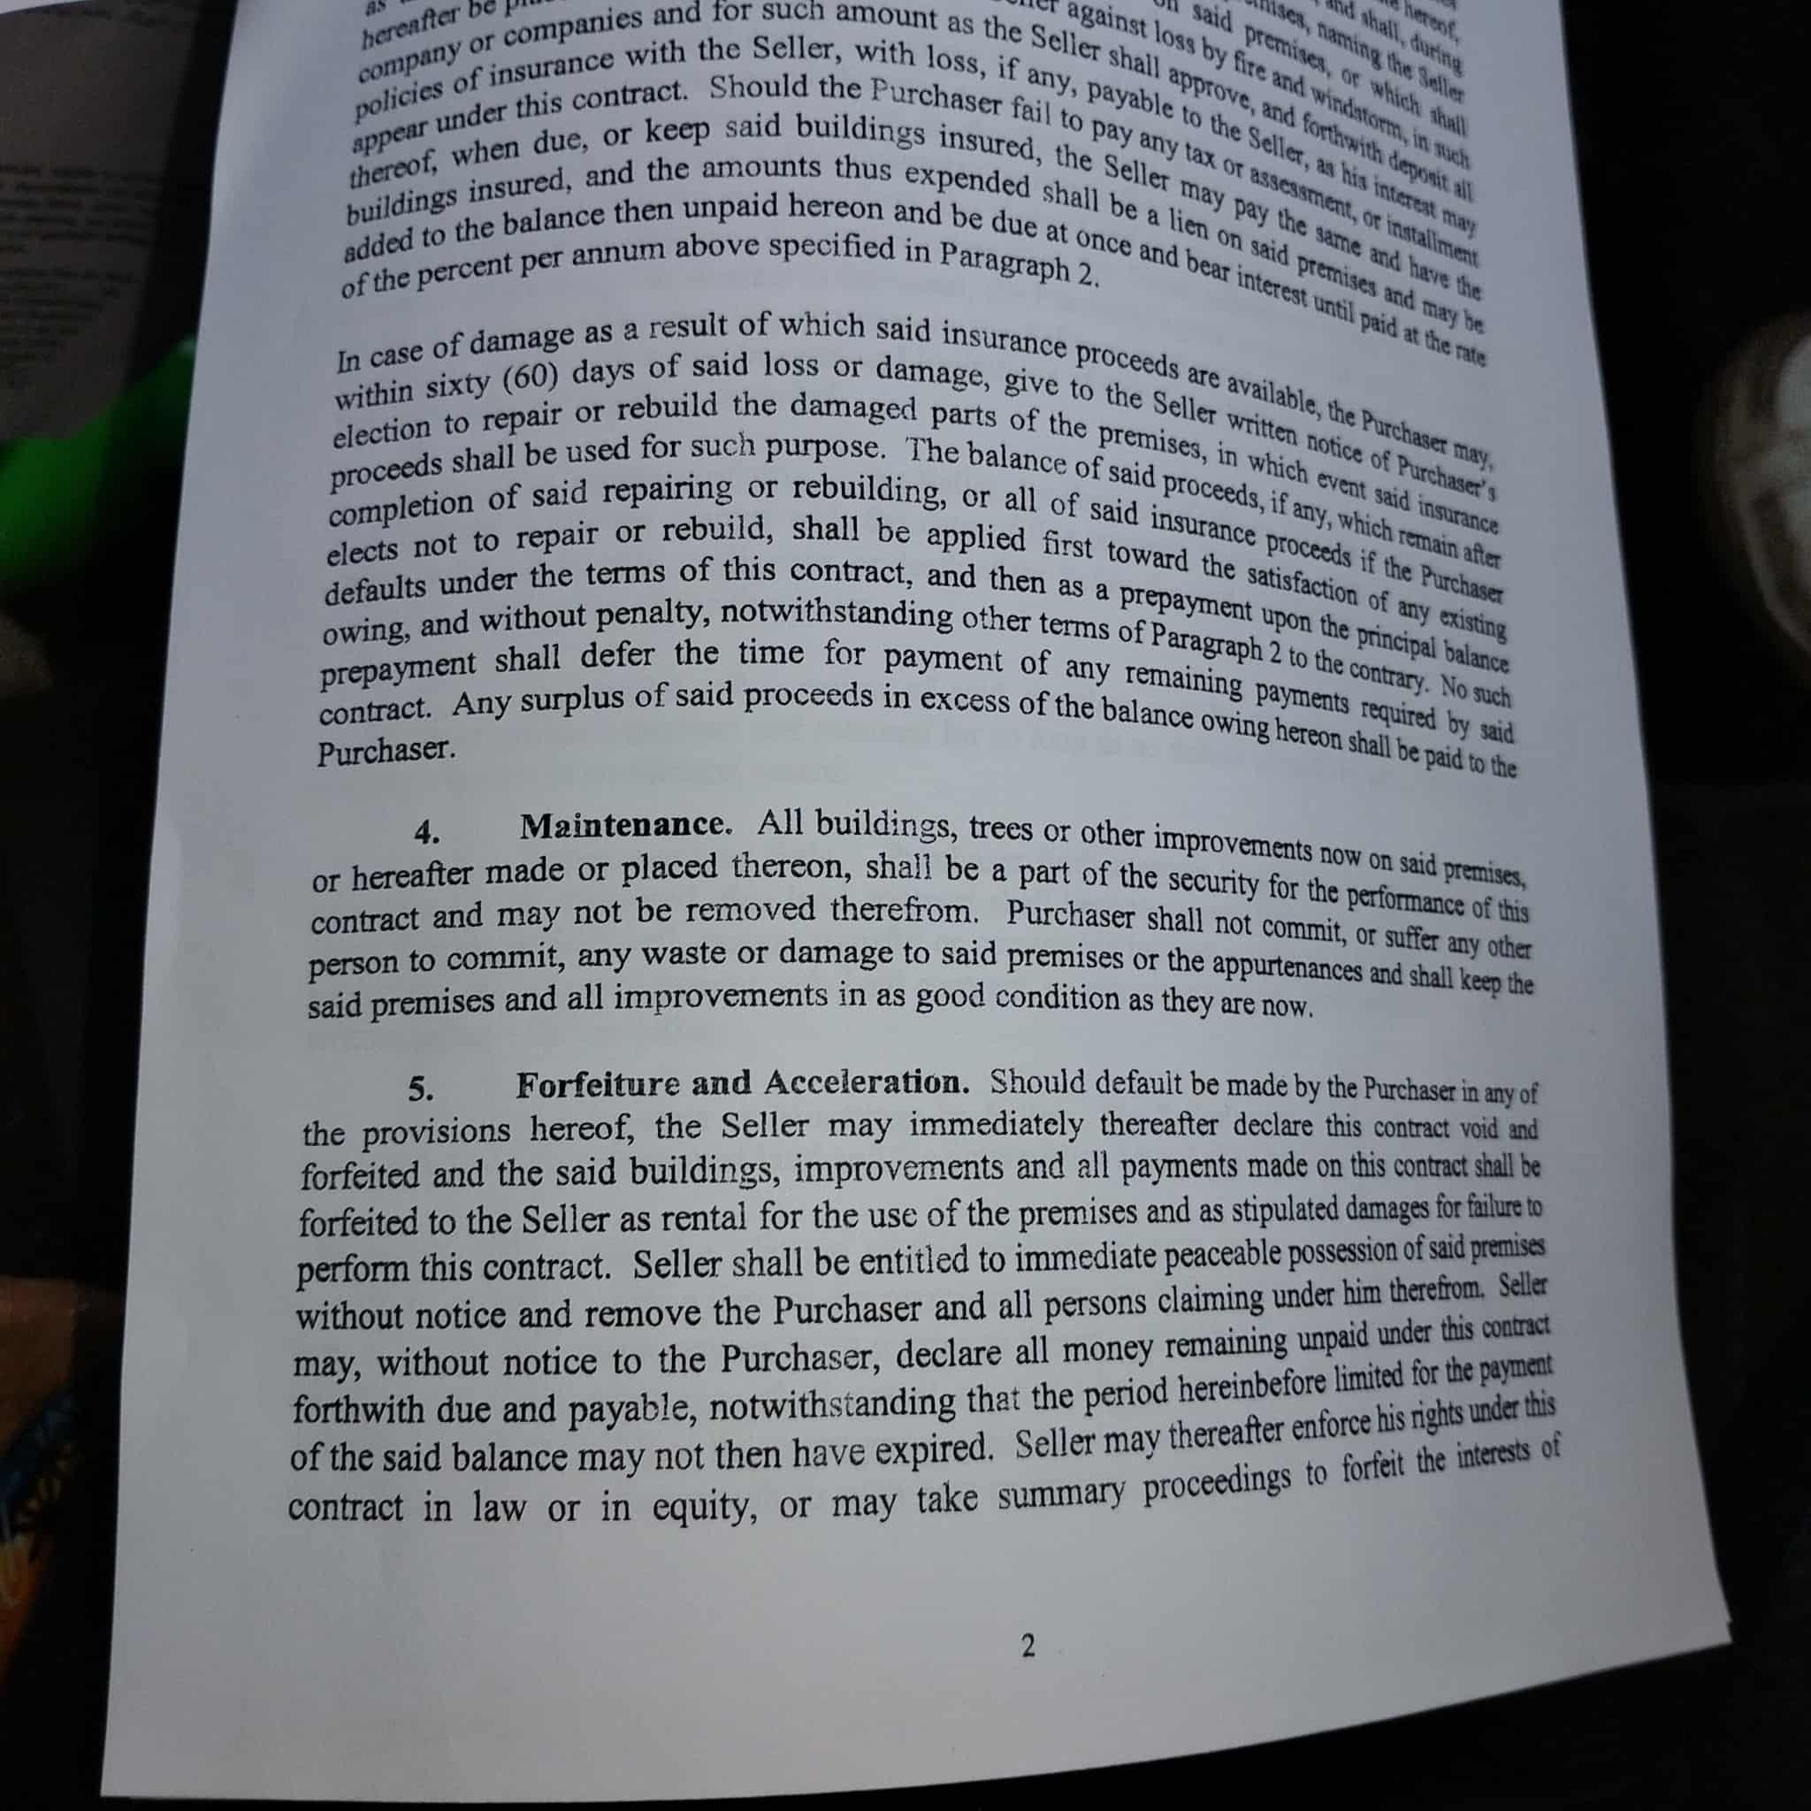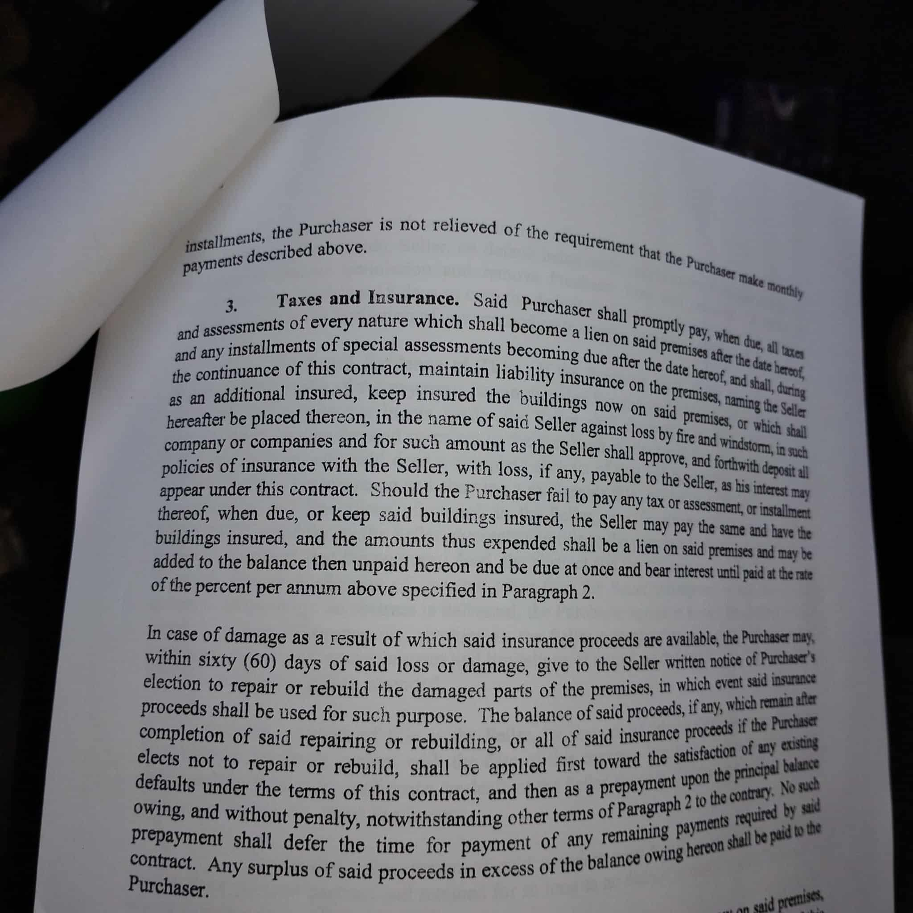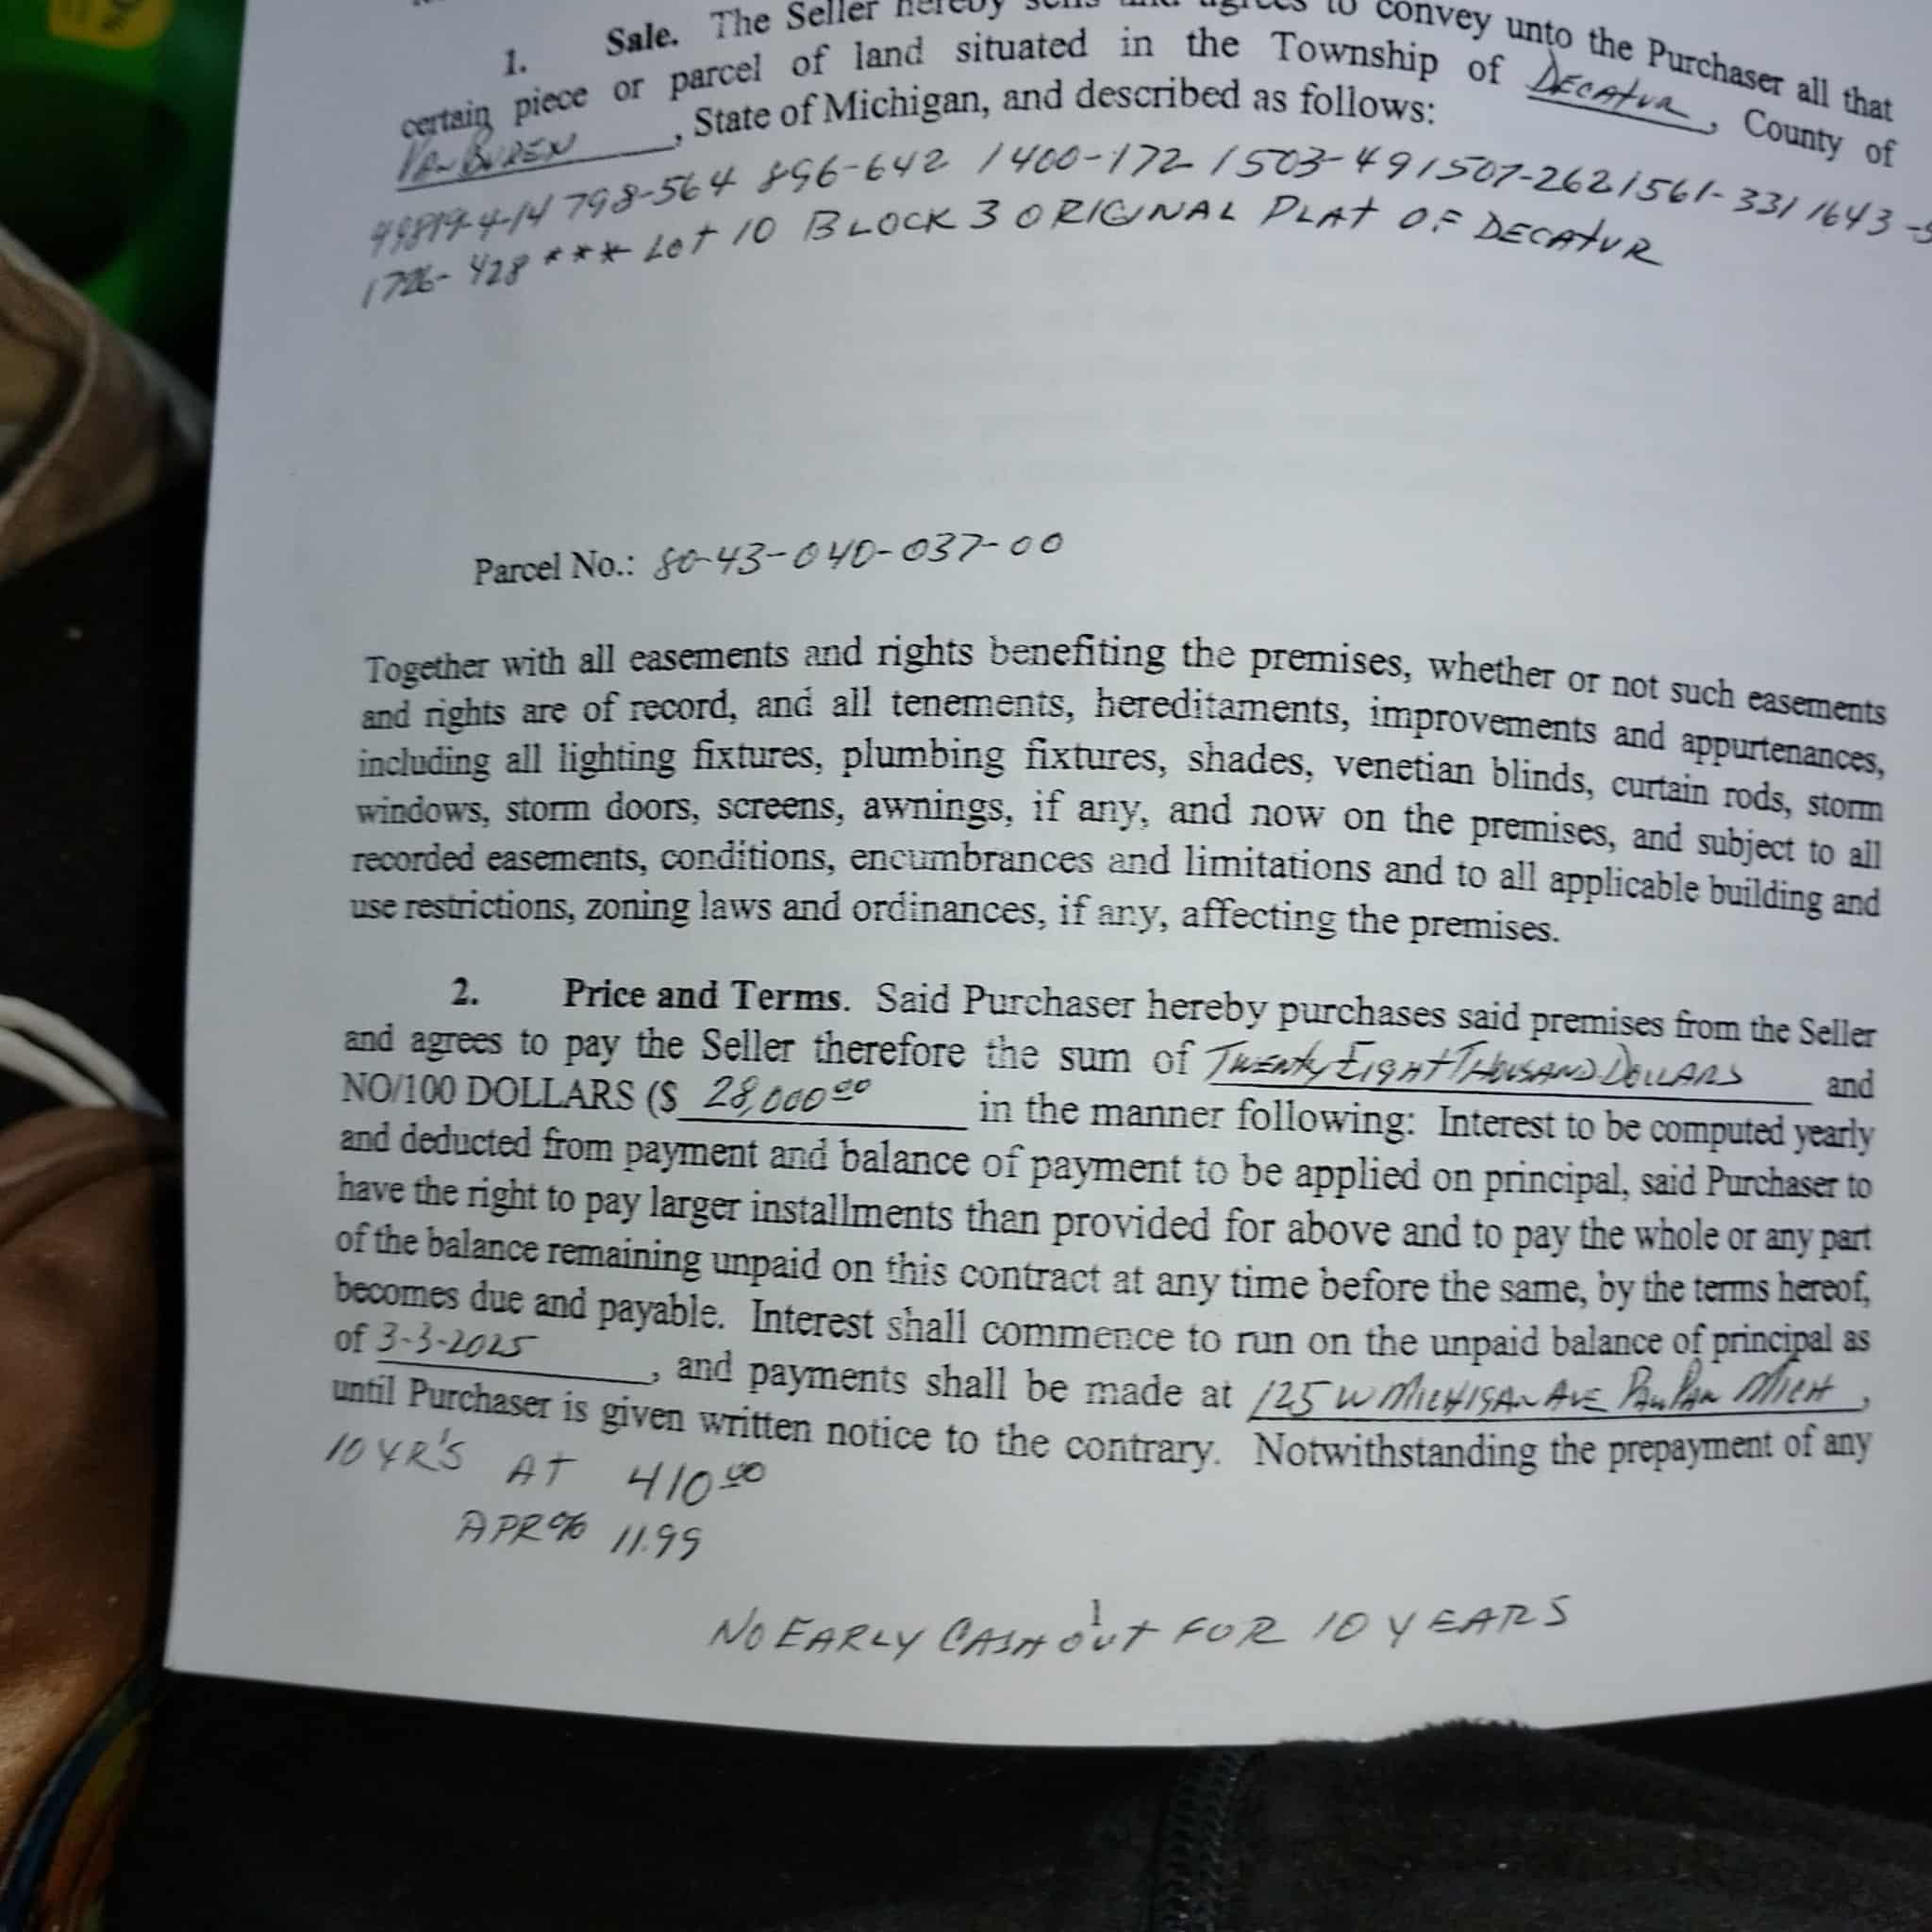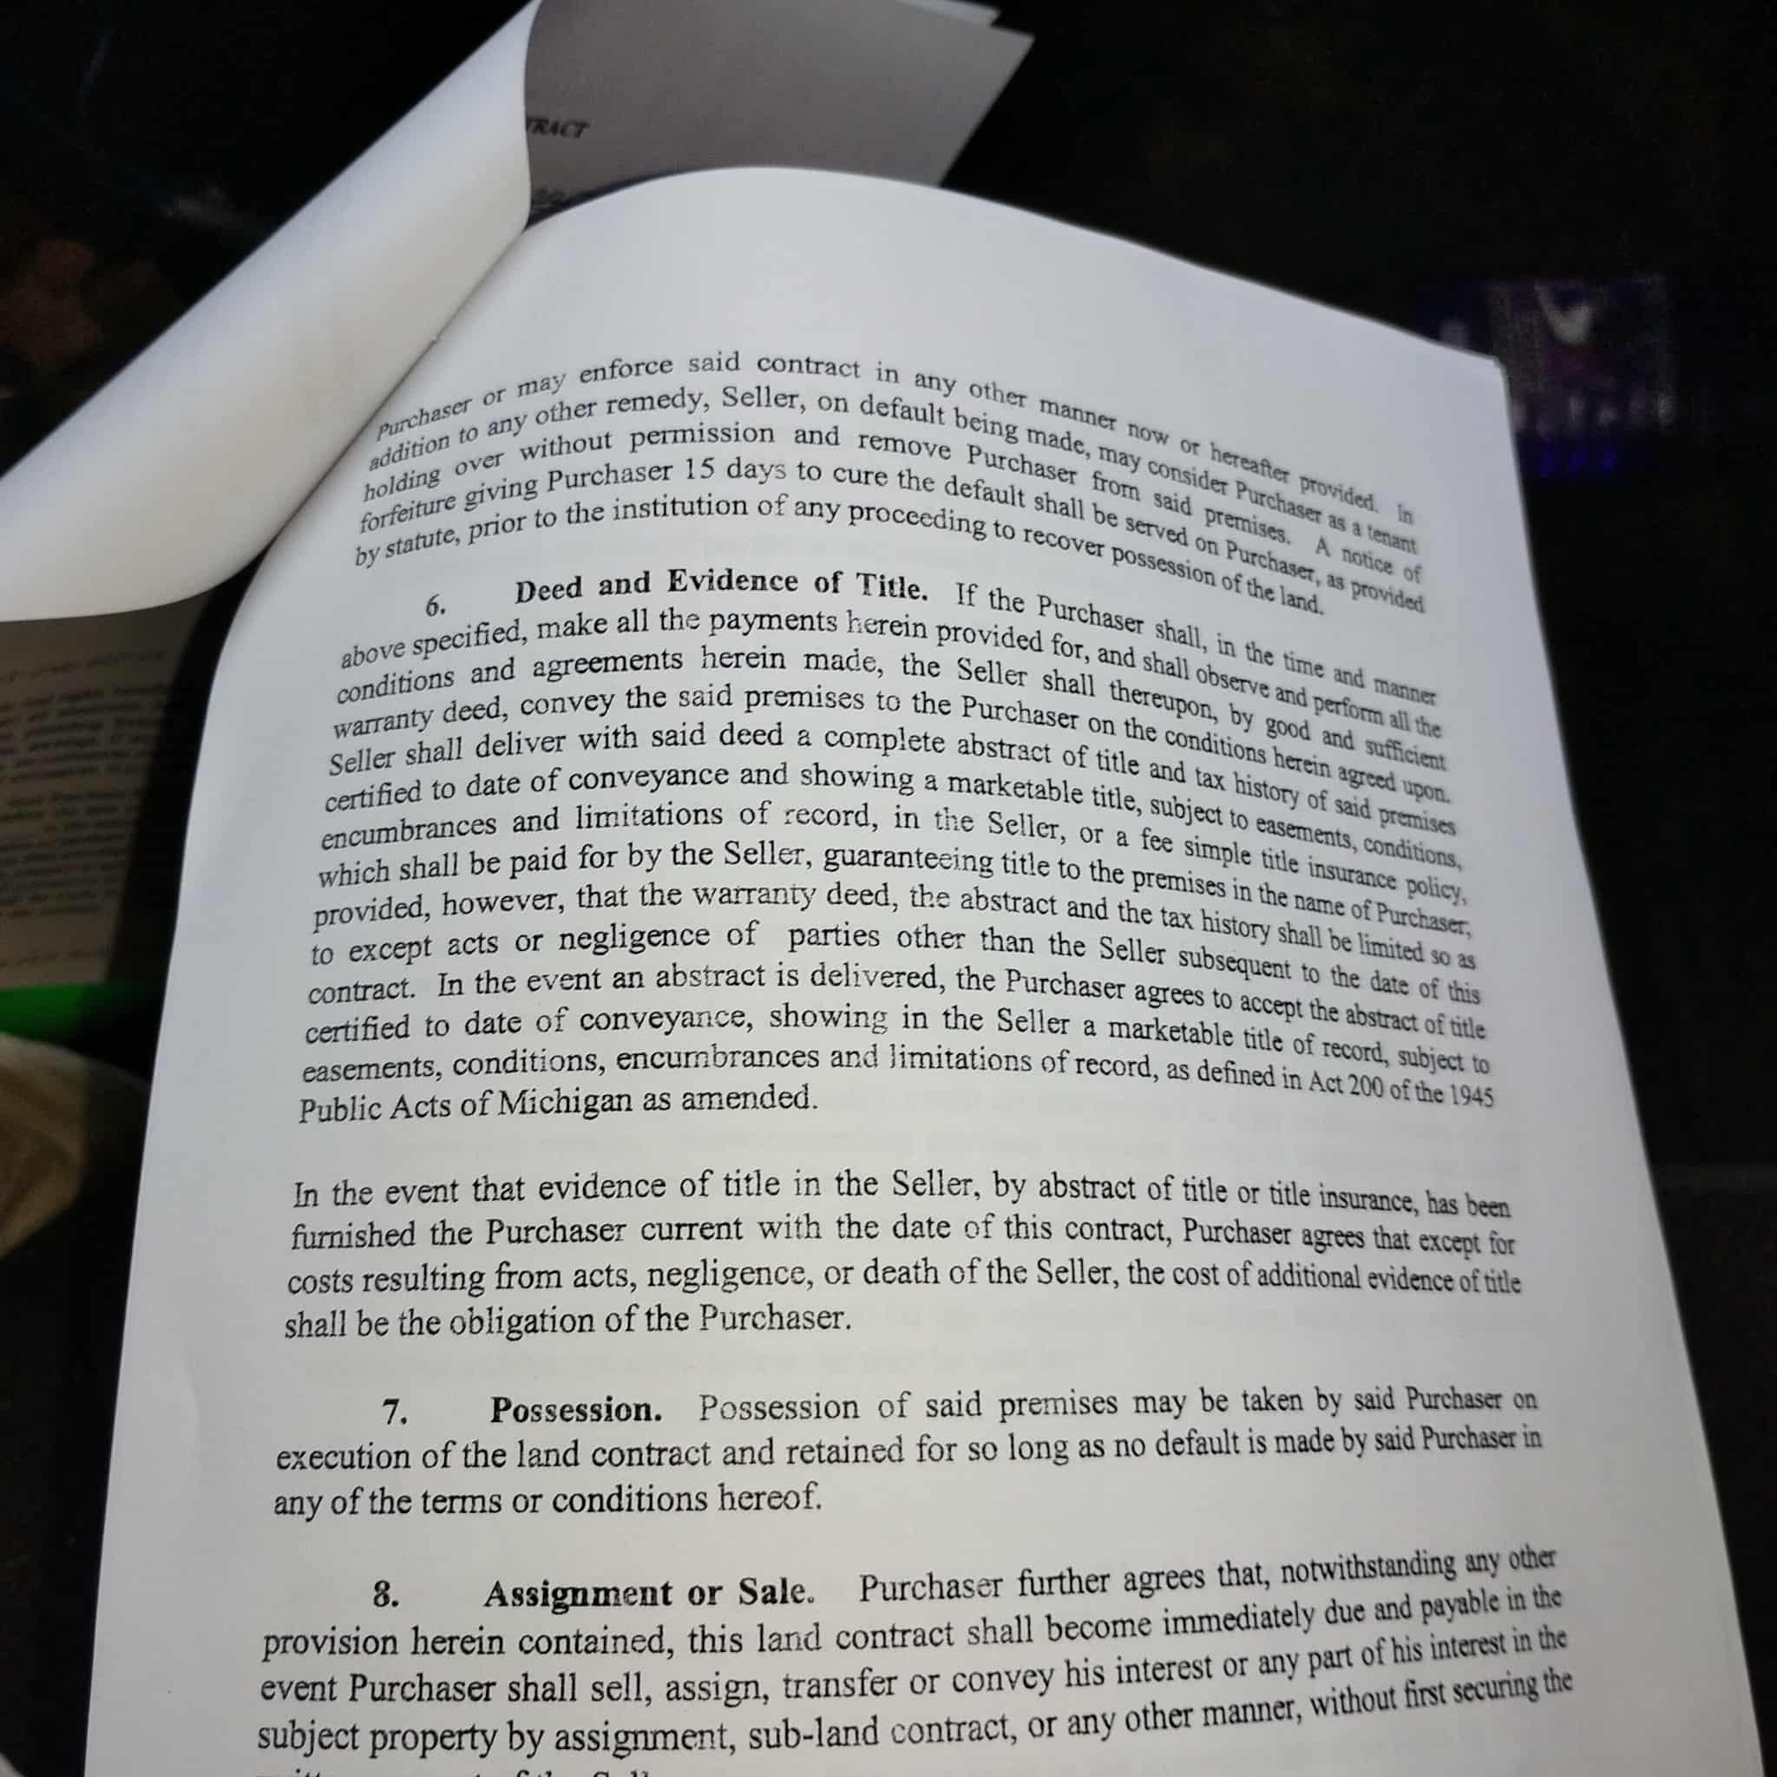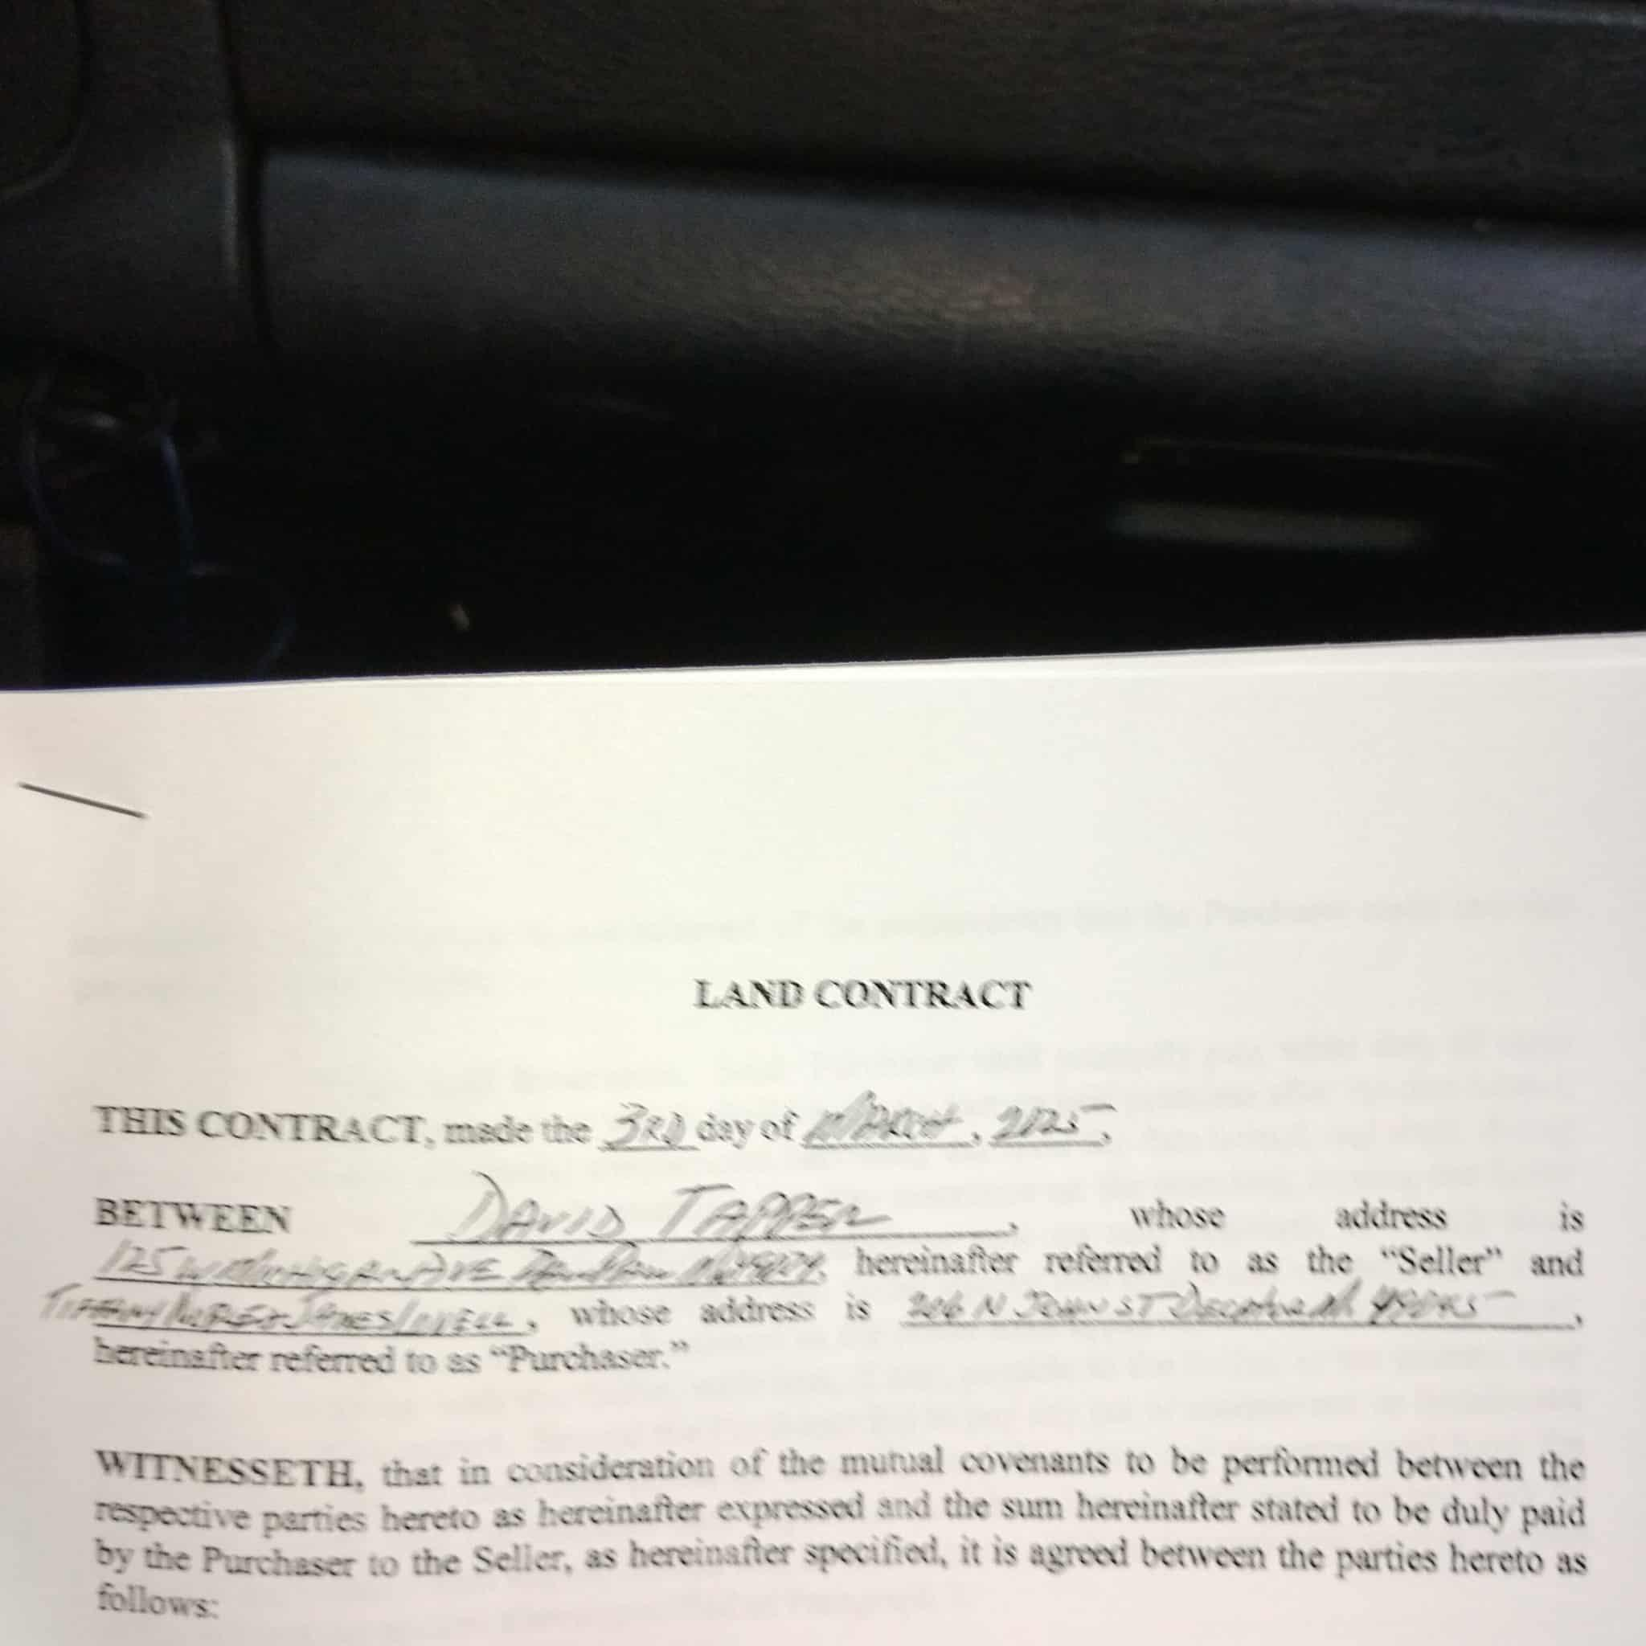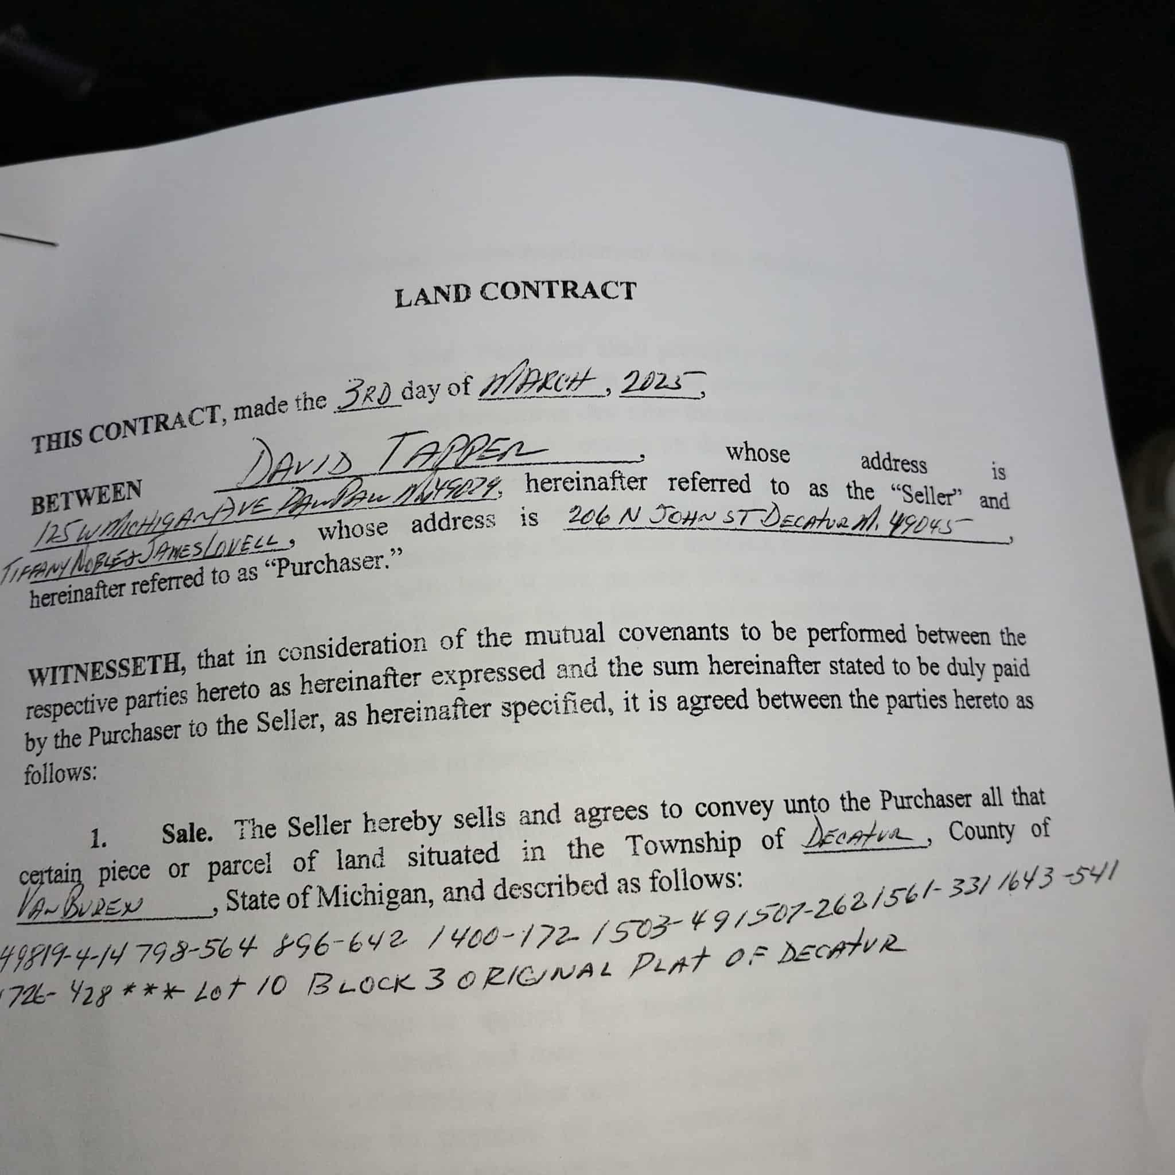
e8abe863-ca50-43ad-b6dc-de074434d4c2.jpg

OCR Error: Failed to load image
See this Instagram photo by @unfreaky: https://www.instagram.com/p/BvsjJHXhlOq/?utm_source=ig_web_button_share_sheet
Sent from Mail for Windows 10

